Please apply for a developer twitter account for our data mining project. You must carefully read and agree to Twitter’s terms to complete the application, then confirm your email address. You will be asked questions about the purpose of your account (such as academic research, student, etc.).

Steps:

* You will need a twitter account. If you don’t have one, create one before proceeding. Make sure you have a **verified email address** on file before proceeding because it will not allow you to submit your application without an email address.
* After you have a twitter account, you can apply for a developer account (access) at - <https://developer.twitter.com/en/apply-for-access>
* You will be asked a few questions. Here is an example of good responses that will help speed up the approval process.
  + Question - What is your primary reason for using Twitter developer tools?
  + Answer - Choose **doing** **Academic Research** under **Academic**
  + Question - How will you use the Twitter API or Twitter data?
  + Answer - "I am new to Twitter app development and am simply learning how to use the Twitter APIs for educational purposes. "
  + Question - “In English, please describe how you plan to use Twitter data and/or APIs….”
  + Answer – “I am new to Twitter app development. I am learning about how to use APIs and simply wanted to use the Twitter APIs for educational purposes. This is for an advanced python course that I am taking in the business school of Baylor University.
  + Question – “Are you planning to analyze Twitter data?”
  + Answer – Yes
  + Explanation - We will be analyzing Twitter to learn how we can use Twitter to do data mining. Specifically, we will be looking at trending topics for location based searches. I would also like to learn how to use Twitter's streaming API. I have no interest in commercial use or gaining any profit. I simply want to use it as a platform to learn the concept of APIs and data mining.
  + All other questions, select No

I got a response from Twitter Developer-accounts asking for more information:

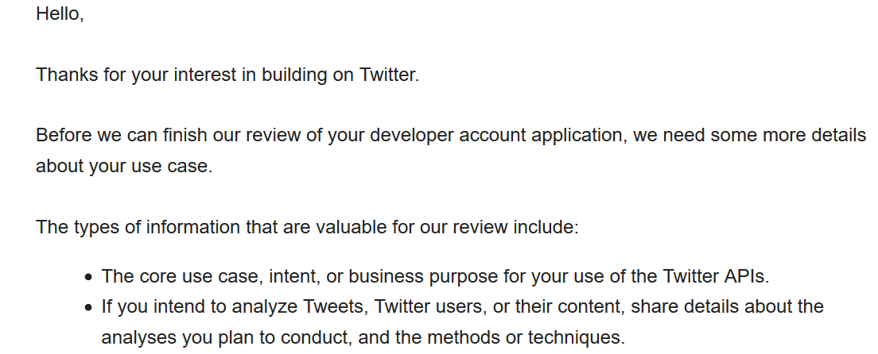

So, in response I emailed back with:

The core use case and purpose of the API is strictly educational. I am trying to learn how to use APIs and interact with it. I am also trying to learn how to do some data mining. Specifically looking at trending topics for location based searches. I would like to know how to use Twitter's streaming API.

I have no plans to do any tweeting, retweeting or liking

I have no plans to display Twitter content off of Twitter

Thank you,

Then I was approved within a couple of hours (on a Sunday too)!

